Bangladesh Medical Association (BMA)
List of Life Member-129
24. BMA Jashore Branch

Sl No | Voter No | Voter Details
1 | Voter No  LM-2400001  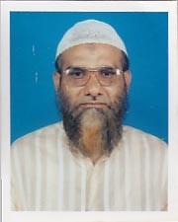 | DR. SYED HASAN IMAM  F/Name: Syed Wahed Hussain  M/Name:  BM & DC Reg. No:  NID:  Cell:  Address: 2-3, Ghope Central Road Jessore  Blood Group:
2 | Voter No  LM-2400002  No Image | DR. RIFAT NASSER AL RAHMAN  F/Name: Late Md. Bazlur Rahman  M/Name:  BM & DC Reg. No:  NID:  Cell:  Address: 33-34, H. M. M. Road, Loan Office Para Jessore  Blood Group:
3 | Voter No  LM-2400003  No Image | DR. FARZANA NAHEED  F/Name: Late Md. Bazlur Rahman  M/Name:  BM & DC Reg. No:  NID:  Cell:  Address: 33-34, H. M. M. Road, Loan Office Para Jessore  Blood Group:
4 | Voter No  LM-2400004  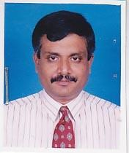 | DR. GOBINDA CHANDRA BOSE  F/Name: Late Jetendra Nath Bose  M/Name:  BM & DC Reg. No:  NID:  Cell:  Address: 28/A, B.K. Road Bejpara Jessore  Blood Group:
5 | Voter No  LM-2400005  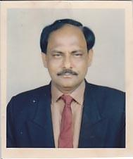 | DR. MD. HARUN AR RASHID  F/Name: Late Daulat Ali Bepari  M/Name:  BM & DC Reg. No:  NID:  Cell: 01711467833  Address: Asso.Professor Of Orthopedic Surgery Ekota Hospital Pvt. Ltd., Sadar Hospital Road .Jessore  Blood Group:
6 | Voter No  LM-2400006  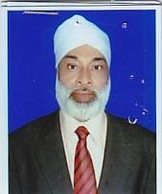 | DR. FAZOL MOBARAK HOSAIN  F/Name: Mohammad Ali Hiru  M/Name:  BM & DC Reg. No:  NID:  Cell:  Address: Surgical Clinic Noapara Jessore  Blood Group:
7 | Voter No  LM-2400007  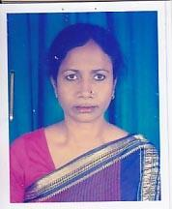 | DR. NASRIN SULTANA  F/Name: Late Rajab Ali  M/Name:  BM & DC Reg. No:  NID:  Cell:  Address: Medical Officer, Abay Nagar Thana Health Complex Jessore  Blood Group:
8 | Voter No  LM-2400008  No Image | DR. MD. AKRAM ALI MOLLAH  F/Name: Nasiruddin Mollah  M/Name:  BM & DC Reg. No:  NID:  Cell:  Address: UH & FPO, Thana Health Complex Abhoynagar, Jessore  Blood Group:  E X P I R E D
9 | Voter No  LM-2400009  No Image | DR. SHAIKH ABDUL KADIR  F/Name:  M/Name:  BM & DC Reg. No:  NID:  Cell:  Address: Consultant, Chest Diseases Clinic Jessore  Blood Group:
10 | Voter No  LM-2400010  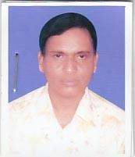 | DR. DILIP KUMAR ROY  F/Name: Gonesh Chandra Roy  M/Name:  BM & DC Reg. No:  NID:  Cell:  Address: Health Complex,Keshabpur, Jessore.  Blood Group:
11 | Voter No  LM-2400011  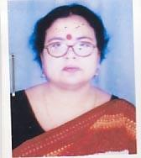 | DR. ANJOLI ROY  F/Name: Manindra Chandra Roy  M/Name:  BM & DC Reg. No:  NID:  Cell:  Address: a  Blood Group:
12 | Voter No  LM-2400012  No Image | DR. M. SHAMSUL HAQUE  F/Name:  M/Name:  BM & DC Reg. No:  NID:  Cell:  Address: Consultant, Eye General Hospital Jessore  Blood Group:
13 | Voter No  LM-2400013  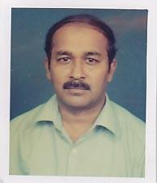 | DR. M.M. ANISUR RAHMAN  F/Name: Md. Iman Ali Moral  M/Name:  BM & DC Reg. No:  NID:  Cell:  Address: 250 Bedded Central Hospital Jessore  Blood Group:
14 | Voter No  LM-2400014  No Image | DR. MD. ABDUR ROUF  F/Name: Md. Mokshed Ali  M/Name:  BM & DC Reg. No:  NID:  Cell:  Address: Asstt. Registrer ENT, General Hospital Jessore  Blood Group:
15 | Voter No  LM-2400015  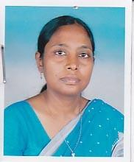 | DR. SALEHA KHATOON  F/Name: Md. Mujibur Rahman  M/Name:  BM & DC Reg. No:  NID:  Cell:  Address: Junior Consultant, Gynae 250 Bed General Hospital Jessore  Blood Group:
16 | Voter No  LM-2400016  No Image | DR. MD. SHAH ZAMAN  F/Name: Late Md. Amirul Hoque  M/Name:  BM & DC Reg. No:  NID:  Cell:  Address: Consultant, Eye 250 Bed General Hospital Jessore  Blood Group:
17 | Voter No  LM-2400017  No Image | DR. S.M. SHAHABUL KARIM  F/Name: Afiluddin Sarder  M/Name:  BM & DC Reg. No:  NID:  Cell:  Address: Junior Consultant, Ortho. 250 Bed General Hospital Jessore  Blood Group:
18 | Voter No  LM-2400018  No Image | DR. MOHAMMAD IZHARUL FAIZ KHAN  F/Name: Mohammad Mosharraf Hossen  M/Name:  BM & DC Reg. No:  NID:  Cell:  Address: UH&FPO, Bagherpara, Jessore  Blood Group:  E X P I R E D
19 | Voter No  LM-2400019  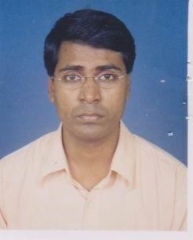 | DR. MD. MONIR HASAN  F/Name: Md. Ziaul Hossain  M/Name:  BM & DC Reg. No:  NID:  Cell:  Address: DCH (Examinee), 250, Bedded Gural Hospital Jessore  Blood Group:
20 | Voter No  LM-2400020  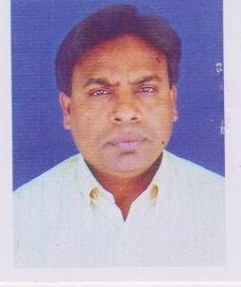 | DR. MD. ABDUL GAFFAR  F/Name: Md. Abdul Hamid Mollah  M/Name:  BM & DC Reg. No:  NID:  Cell:  Address: Doctors Clinic Hospital Raod,Noapara Jessore.  Blood Group:
21 | Voter No  LM-2400021  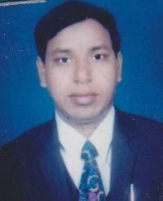 | DR. MD. TOWHID-UZ-ZAMAN  F/Name: Late M.a. Kashem  M/Name:  BM & DC Reg. No:  NID:  Cell:  Address: Consultant, Lion Eye Hospital, Hustala, Jessore.  Blood Group:
22 | Voter No  LM-2400022  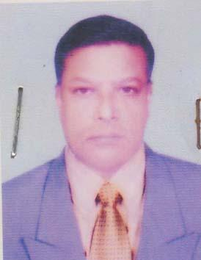 | DR. MOHAMMAD HEDAYETUL ISLAM  F/Name: Late Md. Ebadullah  M/Name: Late Begum Badrunnesa  BM & DC Reg. No: 9551  NID: 4123802356147  Cell: 01712248106  Address: Assistant Director (Administration-1) DGHS, Keshobpur Bazar, Jessore  Blood Group: B+
23 | Voter No  LM-2400023  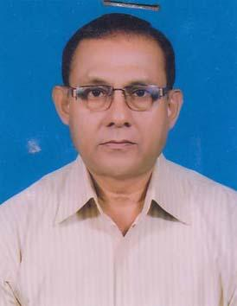 | DR. G. K. M. KAMARUZZAMAN  F/Name: Late. Abdur Razzaque  M/Name: Late. Momena Begum  BM & DC Reg. No: 10919  NID: 4124704051610  Cell: 01711351112  Address: 99. Garibshah Road Puratan Kashba, Kotwali, P.S, Jessore  Blood Group:
24 | Voter No  LM-2400024  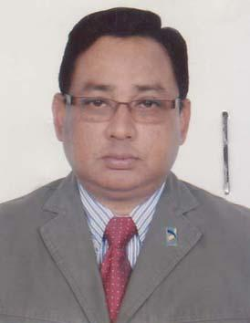 | DR. AKM KAMRUL ISLAM (BENU)  F/Name: Late Abdus Sattar  M/Name: Late Anwara Begum  BM & DC Reg. No: 16231  NID: 4124702018305  Cell: 01718028747  Address: 52A Ambika Bosu Lane Banaripara, Jessore  Blood Group: B+
25 | Voter No  LM-2400025  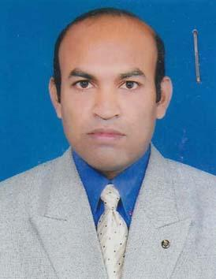 | DR. DAVID TONMOY BISWAS  F/Name: Late Simon Benith Biswas  M/Name: Late Promila Rani Biswas  BM & DC Reg. No: 31178  NID:  Cell: 01718312754  Address: 45, Air Port Road, Jessore  Blood Group: O+
26 | Voter No  LM-2400026  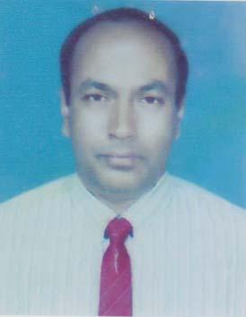 | DR. AMAL KUMAR BISWAS  F/Name: Late Baburam Biswas  M/Name: Late Amela Biswas  BM & DC Reg. No: 10599  NID: 4124708112909  Cell: 01712010657  Address: Consultant (Zye) Sador Hospital, Satkhira  Blood Group:
27 | Voter No  LM-2400027  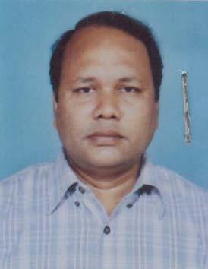 | DR. SHEIKH FARUQUE AHMED  F/Name: Sheikh Abul Hashem  M/Name: Sofia Sultana  BM & DC Reg. No: 20426  NID: 4124704041929  Cell: 01711350600  Address: 30/A, Sahid Moshiur Rahman Road, Kotwali, Jessore  Blood Group:
28 | Voter No  LM-2400028  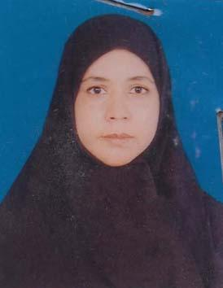 | DR. SHAHANARA KHATOON  F/Name: Late. Md. Sakhawat Hossain  M/Name: Late Begum Sahanara Hossain  BM & DC Reg. No: 17252  NID: 4124704051730  Cell: 01714442552  Address: Consultant Sonologist Ekota Hospital Jessore  Blood Group: O+
29 | Voter No  LM-2400029  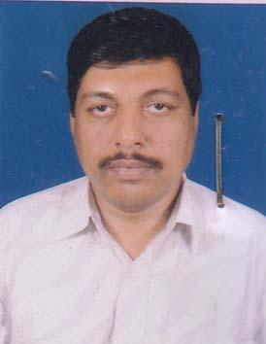 | DR. JAYANTA KUMAR PODDER  F/Name: Late Panchanon Poddar  M/Name: Late Sudha Rani Poddar  BM & DC Reg. No: 17329  NID: 4124703032539  Cell: 01552676185  Address: 4, Rani Road, Jessore  Blood Group: B+
30 | Voter No  LM-2400030  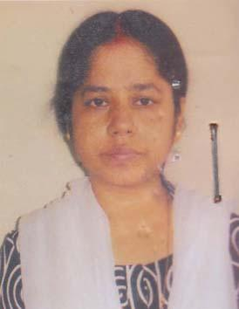 | DR. TINKU RANI ROY  F/Name: Dulal Krishna Roy  M/Name: Mina Rani Roy  BM & DC Reg. No: 25452  NID: 4124703032541  Cell: 01715623043  Address: C/O Dr. Joyanta Kr. Podder, 4 Rail Road, Jessore  Blood Group: B+
31 | Voter No  LM-2400031  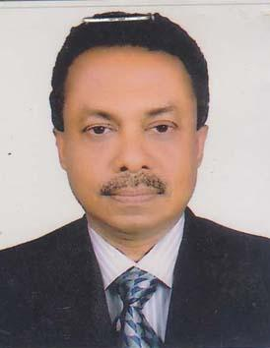 | DR. MD NASIM REZA  F/Name: Md. Nurul Huda  M/Name: Jobeda Khatun  BM & DC Reg. No: 17506  NID: 4124705055215  Cell: 01711899226  Address: Puratan Kashba, 30, Karbala Road, Jessore-7400  Blood Group: A+
32 | Voter No  LM-2400032  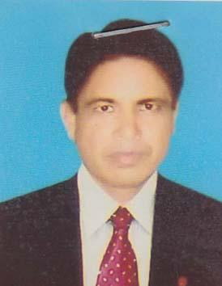 | DR. MD. MOSTAFIZUR RAHMAN  F/Name: Md. Dabir Uddin  M/Name: Mrs. Rigia Begum  BM & DC Reg. No: 21685  NID: 4122303784746  Cell: 01711266608  Address: Sigma Medicare Clinic, Shikargacha, Jessore  Blood Group: O+
33 | Voter No  LM-2400033  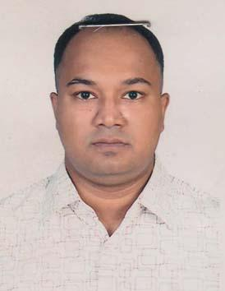 | DR.KAZI IKRAMUL HAQUE  F/Name: Kazi Mofizul Haque  M/Name: Rashida Akhter  BM & DC Reg. No: 44837  NID: 41247070927  Cell: 01714083767  Address: 65, Chopdarpara Road, Bespara, Jessore  Blood Group: B+
34 | Voter No  LM-2400034  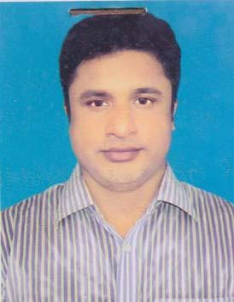 | DR. GOUTAM KUMAR ACHERJYA  F/Name: Late Shadhan Kumar Acherjya  M/Name: Late Shondary Acherjya  BM & DC Reg. No: 35805  NID: 6125214204409  Cell: 01711029790  Address: Pathologist, 250 Bedded General Hospita, Jessore  Blood Group: O+
35 | Voter No  LM-2400035  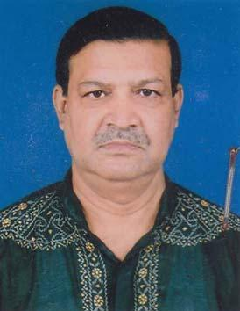 | DR. MD. ATIQUR RAHMAN KHAN  F/Name: Late Obaidur Rahman Khan  M/Name: Momtaj Nahar  BM & DC Reg. No: 10835  NID:  Cell: 01712810716  Address: 264 Gope Nath Pur,Road,Jessore  Blood Group: B+
36 | Voter No  LM-2400036  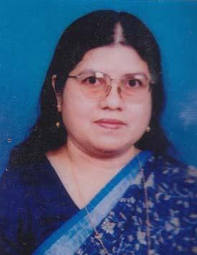 | DR. RASHIDUN NESSA  F/Name: Late Taher Ali  M/Name: Hazera Ali  BM & DC Reg. No: 11517  NID: 4124703036671  Cell: 01715368807  Address: 264, Ghope, Noapara Road, Jessore  Blood Group: B+
37 | Voter No  LM-2400037  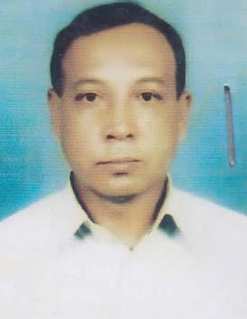 | DR. MD. NASIR UDDIN  F/Name: Late- Helal Uddin  M/Name: Late- Hasina Khatun  BM & DC Reg. No: 15044  NID: 4154798193435  Cell: 01711183887  Address: Upazila Health & Family Planning Officer, Sharsha, Jessore  Blood Group: A+
38 | Voter No  LM-2400038  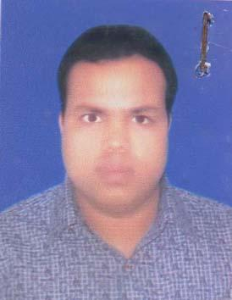 | DR. MD. HABIBUR RAHMAN  F/Name: Md. Korban Ali  M/Name: Most. Johora Khatun  BM & DC Reg. No: 45124  NID:  Cell: 01711337412  Address: Vill+P.O- Baganchara, Thana- Sharsha Dist- Jessore  Blood Group: O+
39 | Voter No  LM-2400039  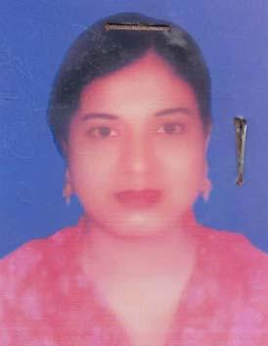 | DR. NAZ MUNNAHAR BINTA ABDUL KHALEQUE  F/Name: Md. Abdul Khaleque Khan  M/Name: Hasina Banu  BM & DC Reg. No: 48652  NID:  Cell: 01714572143  Address: Vill+P.o- Baganchara, Thana- Sharsha, Dist- Jessore  Blood Group: B+
40 | Voter No  LM-2400040  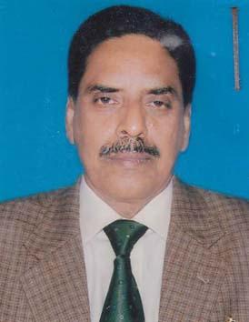 | DR. MD. RAUSHAN ANWAR  F/Name: Md. Anwarul Kabir  M/Name: Raushan Ara Banu  BM & DC Reg. No: 14972  NID: 4124705059222  Cell: 01715023905  Address: 19/B, Bamon Para Road, Kharki, Jessore  Blood Group: O+
41 | Voter No  LM-2400041  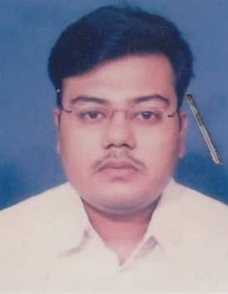 | DR. MD. MOSHFEQ-UR-RAHMAN  F/Name: Late Mizanur Rahman  M/Name: Feroza Aktar  BM & DC Reg. No: 34315  NID: 4124707075636  Cell: 01711104077  Address: 44, Abdul Aziz Road Puraton Kasba, Jessore  Blood Group: O+
42 | Voter No  LM-2400042  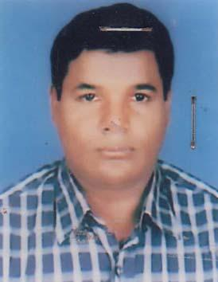 | DR. MADHUSUDAN PAUL  F/Name: Late Shyan Lal Paul  M/Name: Late Bishakha Rani Paul  BM & DC Reg. No: 26409  NID: 4124708106424  Cell: 01712850164  Address: 5 Piary Mohan Road Bejpara Kotwali, Jessore  Blood Group: O+
43 | Voter No  LM-2400043  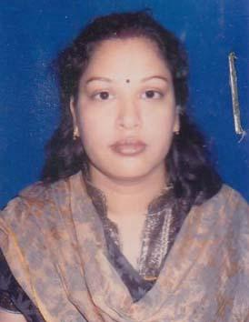 | DR. SEEMA SAHA  F/Name: Ajit Kumar Saha  M/Name: Dipali Rani Saha  BM & DC Reg. No: 49604  NID: 7625503129087  Cell: 01712534853  Address: Vill: Arenda, P.O: Goalda Bazar, P.S: Monirampur, Dist: Jessore  Blood Group: O+
44 | Voter No  LM-2400044  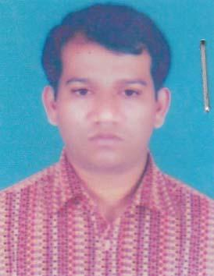 | DR. DEBASISH DUTTA  F/Name: Benoy Krishna Dutta  M/Name: Basanti Dutta  BM & DC Reg. No: 39823  NID: 4116189463701  Cell: 01712052327  Address: Vill- Arenda, P.O- Goaldur Bazar, P.S- Monirampur, Dist- Jessore  Blood Group: O+
45 | Voter No  LM-2400045  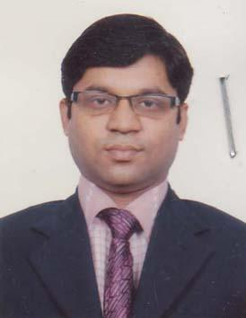 | DR. MD. MAHMUDUL HASAN PANNU  F/Name: Md. Torab Ali  M/Name: Mrs. Ashrafunnesa  BM & DC Reg. No: 45501  NID: 2697557397380  Cell: 01711006087  Address: Asst: Registrar, 250 Beded General Hospital, Jessore  Blood Group: O+
46 | Voter No  LM-2400046  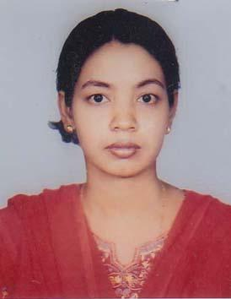 | DR. SANCHITA ADHIKARY  F/Name: Marobilash Adhikary  M/Name: Moni Prova Adhikary  BM & DC Reg. No: 33238  NID: 4124701001794  Cell: 01711362909  Address: 58, Sayatal, City College Para, Jessore  Blood Group: A+
47 | Voter No  LM-2400047  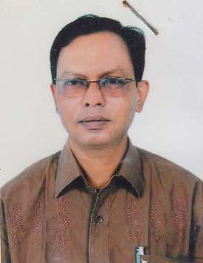 | DR. M.A. BASHAR  F/Name: Late: Abdur Razzaque Sharif  M/Name: Mrs. Fazilatunnesa  BM & DC Reg. No: 18953  NID: 4124706086597  Cell: 01715351944  Address: 32/A, Chitta Ranjan Das Sarak, Rail Road, Jessore  Blood Group: B+
48 | Voter No  LM-2400048  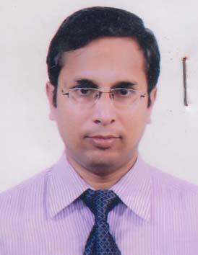 | DR. MOHAMMAD IQBAL HOSAIN  F/Name: Mohammad Afzal Hossain  M/Name: Hamida Begum  BM & DC Reg. No: 37077  NID: 8227604114730  Cell: 01712655236  Address: Jhikargacha Health Complex, Jessore  Blood Group: B+
49 | Voter No  LM-2400049  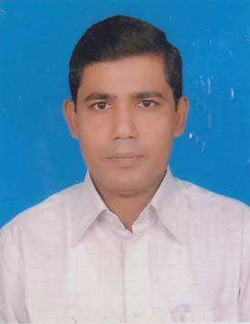 | DR. MD. WAHIDUZZAMAN DITTO  F/Name: Late Shahabuddin Ahmed  M/Name: Rabeya Khatun  BM & DC Reg. No: 32911  NID: 4112365934939  Cell: 01711265135  Address: Anaesthetist, 250 Beded General Hospital, Jessore  Blood Group: A-
50 | Voter No  LM-2400050  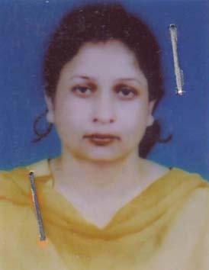 | DR. ELABATI MONDAL  F/Name: Kangali Charan Mondal  M/Name: Choto Rani Mondal  BM & DC Reg. No: 23792  NID:  Cell: 01729504080  Address: 250 Beded General Hospital, Jessore  Blood Group: B+
51 | Voter No  LM-2400051  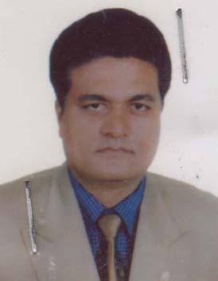 | DR. HEMADRI SHEKHAR SARKER  F/Name: Lakshmi Kanta Sarker  M/Name: Smriti Kana Sarker  BM & DC Reg. No: 24149  NID:  Cell: 01711016225  Address: 250 Beded General Hospital, Jessore  Blood Group: A+
52 | Voter No  LM-2400052  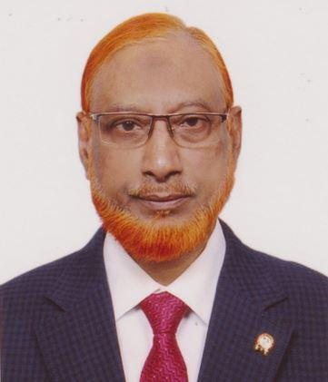 | DR.M.A.SHAMSUL AREFIN  F/Name: Late. Md. Mehdi Hossain  M/Name: Late. Begum Rokeya Sultana  BM & DC Reg. No: 14040  NID: 7762993835  Cell: 01711841485  Address: Kings Medical Services & Hospital, Jashore  Blood Group: O+
53 | Voter No  LM-2400053  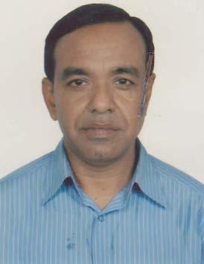 | DR. MD. RABIUL ISLAM  F/Name: Late Mohammad Ali Molla  M/Name: Late Sundori Bibi  BM & DC Reg. No: 16777  NID: 4124705058375  Cell: 01711456673  Address: Asstt. Proff. (Gynae) Jessore Medical College, Jessore  Blood Group:
54 | Voter No  LM-2400054  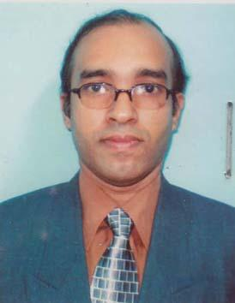 | DR. SK. ABDUL. HAKIM HIMU  F/Name: Sk. Abdul. Nayem  M/Name: Begum. Nargis. Nayem  BM & DC Reg. No: 31886  NID: 4124706086406  Cell: 01711170669  Address: 41, Rail Road, Opposite Food Godawn, Thana- Kotoali, Dist- Jessore  Blood Group: B+
55 | Voter No  LM-2400055  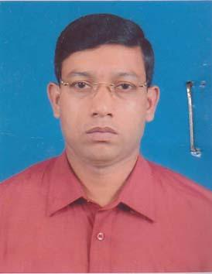 | DR. SHEIKH MOHAMMAD ALI  F/Name: Sheikh. Md. Younus Ali  M/Name: Mrs. Amirun Nesa  BM & DC Reg. No: 27040  NID: 4124706074688  Cell: 01711819609  Address: Junior Consultant (Ortho), 250 Beded General Hospital, Jessore  Blood Group: A+
56 | Voter No  LM-2400056  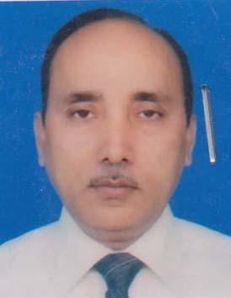 | DR. MD. GOLAM FARUQUE  F/Name: Late Motiullah  M/Name: Amena Khatun  BM & DC Reg. No: 16586  NID: 4124703036974  Cell: 01714022100  Address: 265/A, Ghope, Nowapara Road, Jessore  Blood Group: B+
57 | Voter No  LM-2400057  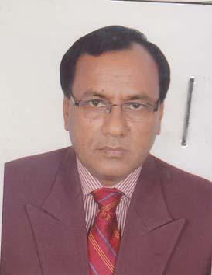 | DR. NIKUNJA BEHARI GOLDER  F/Name: Late Gopal Chandra Golder  M/Name: Late Parul Bala Golder  BM & DC Reg. No: 13047  NID: 4124703027842  Cell: 01711394168  Address: 250 Beded General Hospital, Jessore  Blood Group: B+
58 | Voter No  LM-2400058  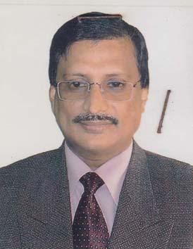 | DR. SALAH UDDIN AHMED  F/Name: Late Dr. Ali Ahmed  M/Name: Mst. Surat Jahan  BM & DC Reg. No: 10606  NID: 4124704051896  Cell: 01715267726  Address: Senior Consultant ENT Cual Superintendent, 250 Beded General Hospital, Jessore  Blood Group: O+
59 | Voter No  LM-2400059  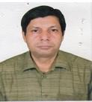 | DR. NUR KUTUBUL ALAM  F/Name: Deen Mohammad Khan  M/Name:  BM & DC Reg. No:  NID:  Cell:  Address: Senior Cosultanst 250 Beded General Hospital, Jessosre.  Blood Group:
60 | Voter No  LM-2400060  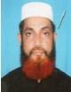 | DR. AKM JAHANGIR ALAM  F/Name: Md. Abdul Wahab  M/Name: Mrs. Majeda Begum  BM & DC Reg. No: 13015  NID: 19602695046971694  Cell: 01711821578  Address: 100, Borhan Uddin Road Jessosre.  Blood Group: O+
61 | Voter No  LM-2400061  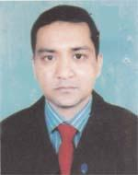 | DR. MD. WOHIDUZZAMAN  F/Name: Md. Mahbubur Rahman  M/Name: Zinnatun Nahar  BM & DC Reg. No: 32694  NID: 2694812084100  Cell: 01711313716  Address: Block A-312, New Town, Jessore  Blood Group: B+
62 | Voter No  LM-2400062  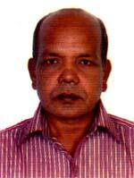 | DR. SANDWIP KUMAR PAUL  F/Name: Shib Nath Paul  M/Name: Bakul Rani Paul  BM & DC Reg. No: 15632  NID: 4124702025054  Cell: 01917229917  Address: 134, HMM Road, Kalter Pool, Jessore  Blood Group: B+
63 | Voter No  LM-2400063  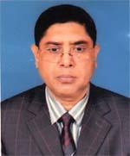 | DR. SWAPAN KUMAR ROY  F/Name: Zadu Nath Roy  M/Name: Chopola Roy  BM & DC Reg. No: 18493  NID: 4124706087215  Cell: 01711368433  Address: 12/Acharja Profulla Chandra Road, Kotwali, Jessore  Blood Group: B+
64 | Voter No  LM-2400064  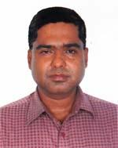 | DR. MD. TOMIZ UDDIN SHEIKH  F/Name: Md. Amzad Hossen Sheikh  M/Name: Hafiza Begum  BM & DC Reg. No: 35605  NID: 4124704053329  Cell: 01711018921  Address: 112, Shasti Tala Para, Mujib Sharok, Jessore  Blood Group: B+
65 | Voter No  LM-2400065  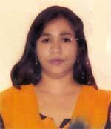 | DR. RIPA SINTHIA BISWAS  F/Name: John Sadhon Biswas  M/Name: Teresa Purabi Biswas  BM & DC Reg. No: 42542  NID: 19794124705055454  Cell: 01712193169  Address: Christian Para, Shahid Swapan Sarak, Jessore  Blood Group: O+
66 | Voter No  LM-2400066  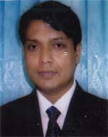 | DR. MAHFUJUR RAHMAN  F/Name: Late Ahmed Ali Tarafder  M/Name: Begum Rahima Khatun  BM & DC Reg. No: 27581  NID: 4124703032516  Cell: 01716204829  Address: Child Health Dept. 250 Bedded Hospital, Jessore  Blood Group: A+
67 | Voter No  LM-2400067  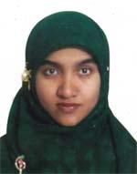 | DR. ISRAT NAZNIN NILA  F/Name: Dr. Abdus Salam  M/Name: Mrs. Anarkoli Salam  BM & DC Reg. No: 44791  NID: 4124703032515  Cell: 01787432311  Address: Medical officer, 250, Bedded General Hospital, Jessore  Blood Group: B+
68 | Voter No  LM-2400068  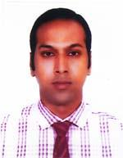 | DR. MD. ASHRAFUZZAMAN  F/Name: Late Robiol Hossain  M/Name: Rizia Hossain  BM & DC Reg. No: 54990  NID: 19864119086673382  Cell: 01712747208  Address: Upazilla Health Complex Chowgacha, Jessore  Blood Group: O+
69 | Voter No  LM-2400069  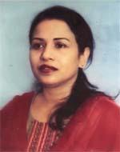 | DR. RINA GHOSH  F/Name: Late Suvendu Ghosh  M/Name: Mira Ghosh  BM & DC Reg. No: 21765  NID: 4798516214554  Cell: 01722822380  Address: 5, Piary Mohan Road, Bejpara, Jessore  Blood Group: B+
70 | Voter No  LM-2400070  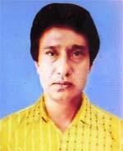 | DR. KALLOL KUMAR SAHA  F/Name: Kumud Ranjan Saha  M/Name: Late Sandhya Saha  BM & DC Reg. No: 26103  NID: 4124708112058  Cell: 01711829396  Address: 5, Piary Mohan Road, Bejpara, Jessore  Blood Group: O+
71 | Voter No  LM-2400071  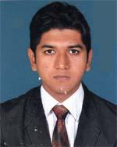 | DR. PARTHO PROTIM CHAKRABARTY  F/Name: Dilip Kumar Chakrabarty  M/Name: Rita Chakrabarty  BM & DC Reg. No: 62920  NID: 0695111184775  Cell: 01714836367  Address: 74/A, Mujib Sorone, Opposite The Jazaroni, Chakro office, Jessore  Blood Group: A+
72 | Voter No  LM-2400072  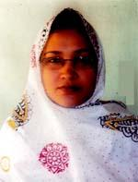 | DR. REBEKA SULTANA  F/Name: Md. Nurujjaman  M/Name: Mrs. Anowara Banu  BM & DC Reg. No: 27052  NID: 2691650160837  Cell: 01712593359  Address: Maligonj, Suparibagan, Jessore  Blood Group: B+
73 | Voter No  LM-2400073  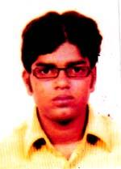 | DR. ANUP KUMAR BASU  F/Name: Dilip Kumar Basu  M/Name: Archana Rani Basu  BM & DC Reg. No: 65044  NID: 8198510364680  Cell: 01719029739  Address: Medical officer, Monirampur Upazilla Health Complex  Blood Group: O+
74 | Voter No  LM-2400074  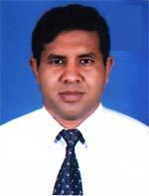 | DR. MD. ANSAR ALI  F/Name: Md. Altaf Hossain  M/Name: Mrs Rabeya Khatun  BM & DC Reg. No: 25361  NID: 2694803577767  Cell: 01711468526  Address: Dharmotology, Jamalpur.  Blood Group: A+
75 | Voter No  LM-2400075  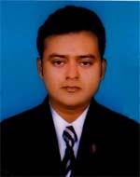 | DR. ARUP JYOTI GHOSH  F/Name: Ashok Kumar Ghosh  M/Name: Protiva Ghosh  BM & DC Reg. No: 48040  NID: 9196203131783  Cell: 01717725382  Address: Asst. Sugeon, UHC, Monirampur, Jessore  Blood Group: B+
76 | Voter No  LM-2400076  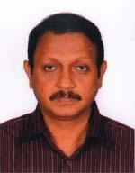 | DR. MD. SHAMSUZZOHA  F/Name: Late Din Mohammad  M/Name: Late Munira Khatun  BM & DC Reg. No: 21591  NID: 4114795249420  Cell: 01715585538  Address: House No.-48, Block-B, N.S.Twon, Jessore  Blood Group: B+
77 | Voter No  LM-2400077  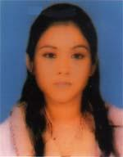 | DR. SHAHLA SHOBNOM  F/Name: Dr. Salahuddin Ahmed  M/Name: Dr. Shahanara Khatun  BM & DC Reg. No: 70198  NID: 19902696513000215  Cell: 01742326327  Address: Shahanara Lodge'97, Garib Shah Road, Jessore.  Blood Group: O+
78 | Voter No  LM-2400078  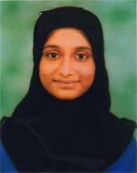 | DR. TASNIM TABASSUM  F/Name: Dr. Salahuddin Ahmed  M/Name: Dr. Shahanara Khatun  BM & DC Reg. No: 74130  NID: 19922696513000473  Cell: 01742326326  Address: 4/3 Paradise Home, 100, Shanti Nagar, Dhaka  Blood Group: O+
79 | Voter No  LM-2400079  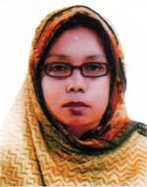 | DR. SAYEDA PARVIN AKTAR  F/Name: Md. Abdur Rouf  M/Name: Sayeda Sajeda Begum  BM & DC Reg. No: 16516  NID: 19632699038633593  Cell: 01199086446  Address: Jessore Medical College, Jessore  Blood Group: B+
80 | Voter No  LM-2400080  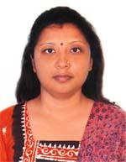 | DR. KEYA TARAFDER  F/Name: Kanshadhar Tarafder  M/Name: Lata Tarafder  BM & DC Reg. No: 40845  NID: 2697556386174  Cell: 01726486538  Address: Gayaram Road, Bejpara, Jessore  Blood Group: A+
81 | Voter No  LM-2400081  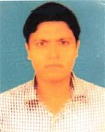 | DR. DEBASISH KUMAR GHOSH  F/Name:  M/Name:  BM & DC Reg. No: 42304  NID: 4112389844839  Cell: 01717591660  Address: Vill-Modhukhali, Post-Bodhkhana, P.s-Jhikargacha, Dist-Jessore  Blood Group: AB+  TRANSFERED to BMA Dhaka City  LM-1405543
82 | Voter No  LM-2400082  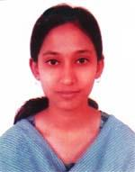 | DR. LAXMI RANI BISWAS  F/Name:  M/Name:  BM & DC Reg. No: 51517  NID: 6125214123350  Cell: 01712181178  Address: Vill-Modhukhali, Post-Bokhkhana, P.s-Jhikargacha, Dist-Jessore  Blood Group: B+  TRANSFERED to BMA Dhaka City  LM-1405543
83 | Voter No  LM-2400083  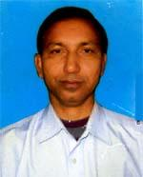 | DR. SANJOY KUMAR PATHAK  F/Name: Late Sushil Kumar Pathak  M/Name: Usha Rani Pathak  BM & DC Reg. No: 17072  NID: 4126108732321  Cell: 01716798748  Address: Monirampur, Jessore  Blood Group: A+
84 | Voter No  LM-2400084  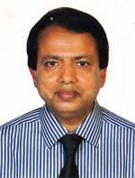 | DR. A. H. M. ABDUR ROUF  F/Name: Late Elahi Baksha  M/Name: Naziron Nesa  BM & DC Reg. No: 18990  NID: 4124706082254  Cell: 01711159034  Address: Asst. Professor (Ortho Surgery), Jessore Medical College, Jessore  Blood Group: A+
85 | Voter No  LM-2400085  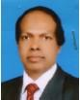 | DR. MD. GIAS UDDIN  F/Name: Late Siddiqur Hussain  M/Name: Mrs. Hasina Khatun  BM & DC Reg. No: 16491  NID:  Cell: 01711172446  Address: United Eye General Hospital, Jessore  Blood Group: B+
86 | Voter No  LM-2400086 | DR. A. H. M. MOSTAFA KAMAL (SAIKAT)  F/Name: Dr. Sk. Md. Abdus Samad  M/Name: Jahanara Khatun  BM & DC Reg. No: 62078  NID: 2694266781324  Cell: 01782734897  Address: House # 24, Sector # 2, New Town, Jessore  Blood Group: A+
87 | Voter No  LM-2400087  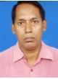 | DR. ABU SAYEED MD ABDUR RAHMAN  F/Name: Md Osman Ghani  M/Name: Mst Rizia Khatun  BM & DC Reg. No: 14438  NID: 4124704041858  Cell: 01711157666  Address: probaho house No-1670, Palbari Traffic More, Jashore.  Blood Group: A+
88 | Voter No  LM-2400088  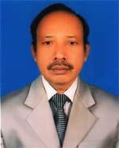 | DR. SUDAN THOMAS HALDER  F/Name: Surin Halder  M/Name: Promila Halder  BM & DC Reg. No: 9492  NID: 19544124704051498  Cell: 01714503114  Address: Hazrat Garib saha Road, Jessore  Blood Group: AB+
89 | Voter No  LM-2400089  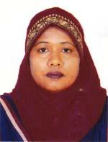 | DR. MST. NARGIS AKHTAR  F/Name: Md. Abu Bakar Biswas  M/Name: Mrs. Shahida Begum  BM & DC Reg. No: 23791  NID: 4110421772578  Cell: 01712013187  Address: 222/Ghope Road, Jessore  Blood Group: A+
90 | Voter No  LM-2400090  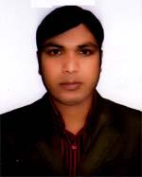 | DR. ANAL ROY  F/Name:  M/Name:  BM & DC Reg. No: 60187  NID: 4798516214702  Cell: 01718737027  Address: Upazilla Health Complex, Monirampur, Jessore  Blood Group: O+  TRANSFERED to BMA Dhaka City  LM-1405543
91 | Voter No  LM-2400091  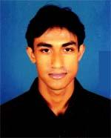 | DR. MD. JOHIRUL HAQUE  F/Name: Md. Amjad Hossain  M/Name: Jahanara Begum  BM & DC Reg. No: 64831  NID: 1595708569639  Cell: 01719391959  Address: Seneho Nir, Madhusudar Road, Keshabpur Bazar, Keshebpur, Jessore  Blood Group: A+
92 | Voter No  LM-2400092  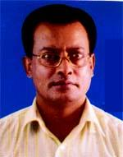 | DR.CHANDRA SHEKHAR KUNDU  F/Name: Nirapada Kundu  M/Name: Parul Rani Kundu  BM & DC Reg. No: 22732  NID: 4126103624056  Cell: 01712253646  Address: UHC, Quarter, Monirampur, Jessore  Blood Group: O+
93 | Voter No  LM-2400093  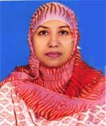 | DR. FOUZIA KHANOM  F/Name: Md. Shah Alom  M/Name: Firoza Alom  BM & DC Reg. No: 32084  NID: 4124706074691  Cell: 01712139928  Address: 34, Rail Road, Shashtitala Para, Jessore  Blood Group: A+
94 | Voter No  LM-2400094  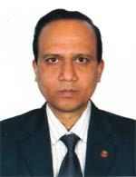 | DR. ALOK KUMAR SARKAR  F/Name: Late Ram Dulal Sarkar  M/Name: Late Gita Rani Sarkar  BM & DC Reg. No: 24187  NID: 8728208158531  Cell: 01712632690  Address: General Hospital Jessore  Blood Group: A+
95 | Voter No  LM-2400095  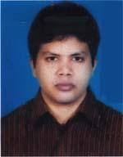 | DR. RAJIB KUMAR PAUL  F/Name:  M/Name:  BM & DC Reg. No: 55370  NID: 19858198510209475  Cell: 01738113706  Address: 74, Muzib Sarak, Jegarani Chakra, Jessore-7400  Blood Group: A+  TRANSFERED to BMA Dhaka City  LM-1405543
96 | Voter No  LM-2400096  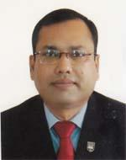 | DR. SHEIKH IQBAL AHMED  F/Name: Sheikh Abul Hashem  M/Name: Sofia Sultana  BM & DC Reg. No: 25512  NID: 4124703033441  Cell: 01711350602  Address: 162/1, Hazrat Goribskah Road, Jessore  Blood Group: A+
97 | Voter No  LM-2400097  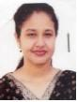 | DR. SUROVI ERA SUCHI  F/Name: Dr. Md. Eyaqub Ali Mollah  M/Name: Ambia Pervin  BM & DC Reg. No: 56059  NID: 19874124703029494  Cell: 01758567356  Address: 127/4, Bonani officer Quater, Bonani,Dhaka  Blood Group: O+
98 | Voter No  LM-2400098  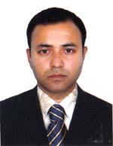 | DR. MIR ABU ZAHID  F/Name: Late Mir Abul Khaled  M/Name: Momena Khatun  BM & DC Reg. No: 52237  NID: 19764124706000011  Cell: 01733640066  Address: Volatan Road, Sostiiala Para, Sadar, Jessore  Blood Group: A+
99 | Voter No  LM-2400099  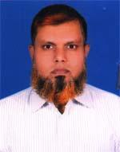 | DR. MD YOUNUS HOSSAIN  F/Name: Md Shamsul Islam  M/Name: Jahanara Khatun  BM & DC Reg. No: 33726  NID:  Cell: 01711930980  Address: 1362/1, Bamon Para Road, Khorki, Jashore  Blood Group: O+
100 | Voter No  LM-2400100  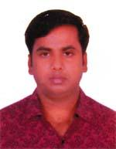 | DR. MD. MAHMUDUL HASAN RASEL  F/Name: M. A. Aziz  M/Name: Hosni Ara Aziz  BM & DC Reg. No: 54112  NID: 9316663791941  Cell: 01716400816  Address: Probaho, 1670, Palbari Traffiaq More, Jessore  Blood Group: A+
101 | Voter No  LM-2400101 | DR. MD. TOUHIDUL ISLAM  F/Name: Md. Abdul Khalek  M/Name: Rowshan Ara Begum  BM & DC Reg. No: 61664  NID: 2924709173830  Cell: 01710875723  Address: Upazilla Health Complex, Monirampur, Jessore  Blood Group: B+
102 | Voter No  LM-2400102  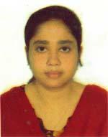 | DR. AFSANA NAZNIN  F/Name: Md. Shahjahan  M/Name: Nurun Nahar  BM & DC Reg. No: 53268  NID: 2617272869078  Cell: 01716200379  Address: Probaho, 1670, Palbari Traffiq More, Jessore  Blood Group: B+
103 | Voter No  LM-2400103  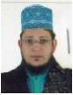 | DR. SHEIKH ZAHID BOKSH  F/Name: Elahi Boksh  M/Name: Fazilatun Nesa  BM & DC Reg. No: 26424  NID: 2694266783973  Cell: 01711344844  Address: Associate Prof. Pediatric JMC  Blood Group: B+
104 | Voter No  LM-2400104  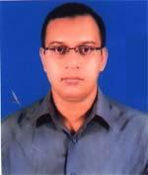 | DR. S.M. MASFIQUR RAHMAN  F/Name: Late Sm Moshiur Rahman  M/Name: Tahmina Begum  BM & DC Reg. No: 34389  NID: 4124706074763  Cell: 01714046388  Address: 14, Basanto Kumar Road, Sostitala Para, Jessore  Blood Group: A+
105 | Voter No  LM-2400105  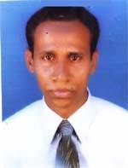 | DR. MD. AZAM SAKLAIN  F/Name: Md. Afsar Ali Mia  M/Name: Hazera Khatun  BM & DC Reg. No: 25196  NID: 8192214340792  Cell: 01712156843  Address: 224, Ghope Nowapara Road, Jessore  Blood Group: B+
106 | Voter No  LM-2400106  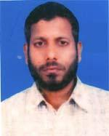 | DR. KAZI ZAMIR HOSSAIN  F/Name: Late Kazi Neyamatulla  M/Name: Late Rabeya Begum  BM & DC Reg. No: 30571  NID: 1424703036073  Cell: 01711003963  Address: Asst. Prof. Addin Sakina Medical College, Jessore  Blood Group: B+
107 | Voter No  LM-2400107  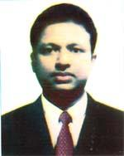 | DR. MOHAMMAD TOHIDUL ISLAM  F/Name: Mohammad Baki Billah  M/Name: Saleha Khanum  BM & DC Reg. No: 36370  NID: 2697557398092  Cell: 01954630805  Address: 19 Surendra Road, Jessore.  Blood Group:
108 | Voter No  LM-2400108  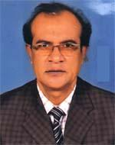 | DR. MD. ABU SUFIAN  F/Name: Md. Abul Hossain  M/Name: Afeson Nela  BM & DC Reg. No: 20861  NID: 4124705058451  Cell: 01711047529  Address: 156-A, Espita Maugin, Misson Para Road, old Cosba, Jessore  Blood Group: B+
109 | Voter No  LM-2400109  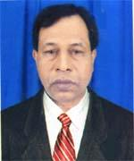 | DR. MD. MASUM ALI  F/Name: Late Hatem Sarder  M/Name: Late Momena Begum  BM & DC Reg. No: 12427  NID: 4114711464602  Cell: 01711450398  Address: Director (Health) Khulna Div. Khulna  Blood Group: A+
110 | Voter No  LM-2400110  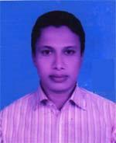 | DR. MD. MAHMUDUL ISLAM  F/Name: Md. Mohidul Islam  M/Name: Mariam Pervin  BM & DC Reg. No: 58547  NID: 4124704041213  Cell: 01717813189  Address: 130/c, Shaheed Mosiur Rahman Road, Palbari , Sadar, Jessore  Blood Group: AB+
111 | Voter No  LM-2400111 | DR. KAZAL MALLICK  F/Name: Swadesh Kumar Mallick  M/Name: Shila Rani Mallick  BM & DC Reg. No: 46896  NID: 4116111467563  Cell: 01717190364  Address: Rabeya Box Mansion , Pilukhan Road, Jail Road, Ghop,Jessore  Blood Group: O+
112 | Voter No  LM-2400112  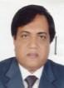 | DR. MD. AMINUR RAHMAN  F/Name: Md. Lutfor Rahman  M/Name: Mrs. Fazilatun Nesa  BM & DC Reg. No: 22536  NID: 4114795255860  Cell: 01911931559  Address: Sector No. 7, House No. E-14, N.S. Town, Jessore  Blood Group: B+
113 | Voter No  LM-2400113  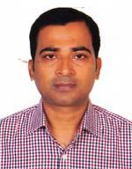 | DR. MD. ALAUDDIN AL MAMUN  F/Name: Md. Atiar Rahman  M/Name: Aleya Begum  BM & DC Reg. No: 41342  NID: 4124708106765  Cell: 01711273315  Address: 96, Bejpara Main Road, Jessore  Blood Group: B+
114 | Voter No  LM-2400114  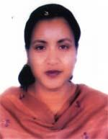 | DR. MONIKA RANI MOHANTA  F/Name: Smriti Bikash Mohanta  M/Name: Priti Rani Mohanta  BM & DC Reg. No: 32781  NID: 9429405118604  Cell: 01717827275  Address: Assist Prof. (Gynee and Obs , Jessore Medical College  Blood Group: B+
115 | Voter No  LM-2400115  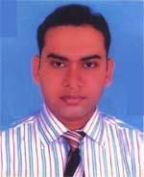 | DR.MUHAMMAD FAZLUL HAQUE KHALID  F/Name: Late. A.n.m. Ansar Uddin  M/Name: Mrs. Jebun Nesa  BM & DC Reg. No: 42488  NID: 2696352220953  Cell: 01717612705  Address: Neuron Sector-07, Plot-D/19, N.S Town, Jessore  Blood Group: O-
116 | Voter No  LM-2400116  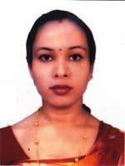 | DR.SHAGORIKA PAULL  F/Name:  M/Name:  BM & DC Reg. No: 63988  NID: 19882910310300348  Cell: 01737377595  Address: 74, Jegdrani Chukrq, Mujib Sarok, Jessore  Blood Group: B+  TRANSFERED to BMA Dhaka City  LM-1405543
117 | Voter No  LM-2400117  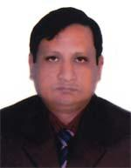 | DR. MD. AKHTARUZZAMAN  F/Name: Md. Abdul Khaleque  M/Name: Anwara Khatoon  BM & DC Reg. No: 15932  NID: 4124705056043  Cell: 01718609878  Address: Associate prof. (ENT) Jessore Medical College Jessore  Blood Group: B+
118 | Voter No  LM-2400118  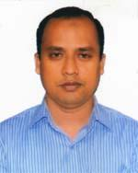 | DR. MD. TAUHIDUR RAHMAN  F/Name: Md. Munsur Rahman  M/Name: Mrs. Hasina Khatun  BM & DC Reg. No: 47392  NID: 6125214204443  Cell: 01834835483  Address: 250 Beded General Hospital, Jessore  Blood Group: A+
119 | Voter No  LM-2400119  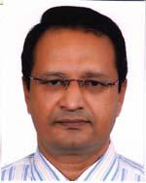 | DR. MD. ABU KAISER  F/Name: Md. Abdul Majid  M/Name: Rawshan Ara Begum  BM & DC Reg. No: 17838  NID: 19632699039523445  Cell: 01720049949  Address: Assit. Prof. Jessore Medical College, Jessore  Blood Group: B+
120 | Voter No  LM-2400120  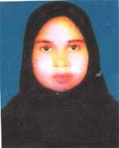 | DR. LAILA NARGIS AKHTER  F/Name: Md. Sadeque Ali  M/Name: Nurun Nahar  BM & DC Reg. No: 40097  NID: 4114741392466  Cell: 01819126916  Address: Doctors Quarter, 250 Beded General Hospital, Jessore  Blood Group: O-
121 | Voter No  LM-2400121  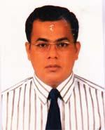 | DR. PRODIP KUMAR GAINE  F/Name: Ajit Kumar Gaine  M/Name: Parul Bala Gaine  BM & DC Reg. No: 27492  NID: 4124708106427  Cell: 01711453474  Address: Ahad Diabetic & Health Complex, Jhumjhumpur, Jessore  Blood Group: O+
122 | Voter No  LM-2400122  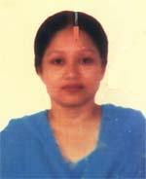 | DR. KANIZ FATEMA  F/Name: Enayet Hossain Khan  M/Name: W.b. Sadeka Haque  BM & DC Reg. No: 45998  NID: 2694067823423  Cell: 01732254640  Address: C-39, New Town, Jessore  Blood Group: A+
123 | Voter No  LM-2400123  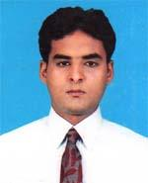 | DR. MD. ABDUS SAMAD  F/Name: Md. Julmot Ali Molla  M/Name: Mst. Amena Khatun  BM & DC Reg. No: 44556  NID: 4110919139005  Cell: 01732565511  Address: 250 Bed. General Hospital, Jessore  Blood Group: O+
124 | Voter No  LM-2400124  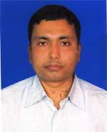 | DR. GOUTAM KUMAR GHOSH  F/Name: Syamal Kumar Ghosh  M/Name: Pritikona Ghosh  BM & DC Reg. No: 37490  NID: 4113885393723  Cell: 01717346874  Address: Vill-Kariakhali, Post-Begumpur, Upazilla-Keshabpur, Dist-Jessore  Blood Group: AB+
125 | Voter No  LM-2400125  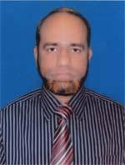 | DR. MD. ABDUR RAHIM MORAL  F/Name: Late Md. Abdus Satter Moral  M/Name: Most. Rabeya Khatun  BM & DC Reg. No: 21584  NID: 4123801353498  Cell: 01711000108  Address: 250 Bedded General Hospital, Jessore senior Consultant, Surgery  Blood Group: B+
126 | Voter No  LM-2400126  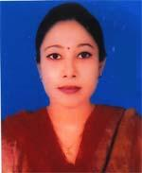 | DR. RUMANA AFRIN ZAMAN  F/Name: Alikadar Md. Shamsuzzaman  M/Name: Joynob Zaman  BM & DC Reg. No: 57230  NID: 2690243843148  Cell: 01733255425  Address: mahbub Mension, house No-7, Pitterson Sunrise Diagnostic Center, Jessore  Blood Group: B+
127 | Voter No  LM-2400127  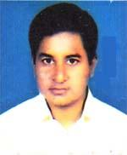 | DR. MD. JAFAR IQBAL  F/Name: Md. Nowab Ali Mondol  M/Name: Sohagi Bibi  BM & DC Reg. No: 46893  NID: 4110966801559  Cell: 01717499508  Address: 119/2, Bylane, Jail Road Ghoph, Jessore  Blood Group: AB+
128 | Voter No  LM-2400128  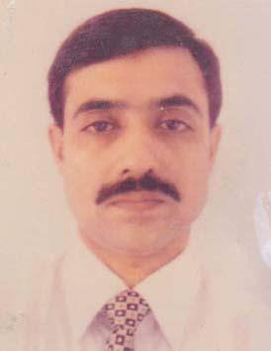 | DR. MD. MARUFUZZAMAN  F/Name: Md. Azizur Rahman  M/Name: Mrs. Hasina Begum  BM & DC Reg. No: 25941  NID: 2697557397783  Cell: 01914389635  Address: Avoyenagar Upazzilla Heth Complex, Jessore  Blood Group: B+
129 | Voter No  LM-2400129  No Image | DR. G M SAFAT ALDIN  F/Name: G M Zillur Rahman  M/Name: Sohela Parvin  BM & DC Reg. No: 85397  NID: 1016303198  Cell: 01914661497  Address: Jassore Sadar Hospital  Blood Group: O+

